CentRes POS

# **Status Update: Sprint** 2 **– Week** 1

**Submitted by:** S. Andy Short

## **TRELLO BOARD**

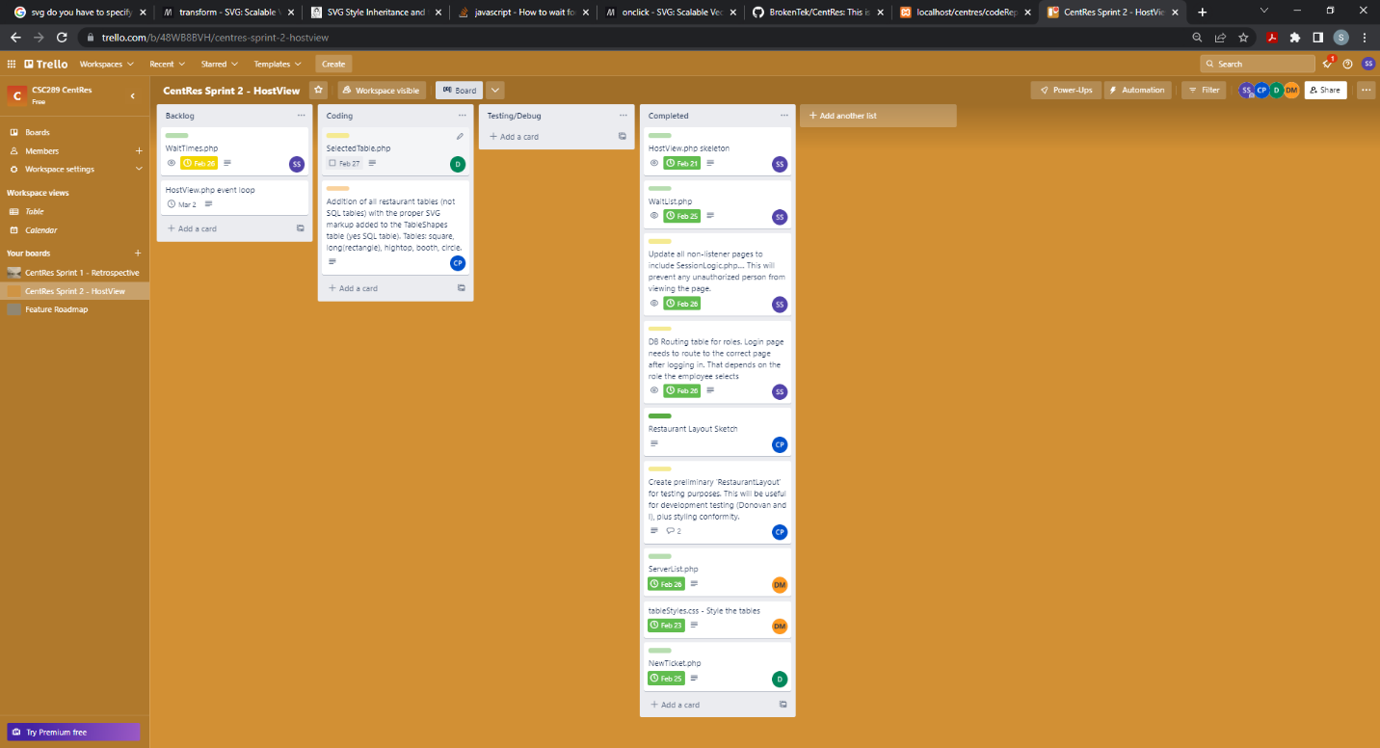

## **STATUS UPDATE DETAILS**

Note: David’s other task, SelectedTable.php, didn’t have enough detail on the wireframe. We had to have a 1 on 1 meeting on 2/25/23 to hammer out the details. A refined wireframe was included illustrating all possible states of this window. Due to the change in effort required to develop this window, David was given a 2 day extension to complete the code (Mon 2/27/23.) He felt certain the php could be completed by that time. This is the reason why he only has 1 task completed for the week.

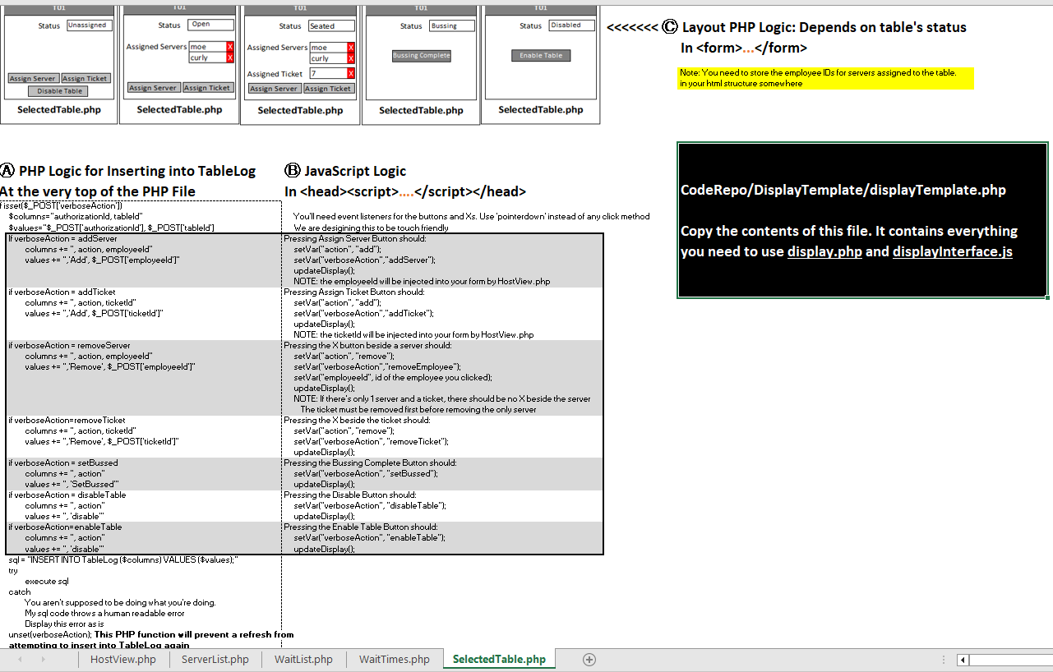

### **Tasks Accomplished (in chronological order)**

1. Created skeleton HostView.php
2. Implemented NewTicket.php
3. Implemented WaitList.php
4. Implemented ActiveServers.php
5. Added routing table in DB to redirect employees to correct home page based upon role.
6. Enhanced sessionLogic.php to redirect to login page if not logged in
7. Enhanced sessionLogic.php to redirect logged in employees accessing privileged page to home page (employee doesn’t have the correct permissions)
8. Updated login page to mark username and password as **readonly** after they are entered, and the employee is selecting role to login as.

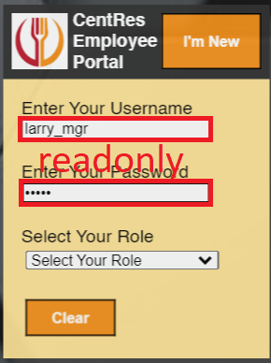

1. Implemented 1 functioning table in RestaurantLayout.php to test with when SelectedTable.php is completed on Monday.

### **Problems/Challenges (include status – “resolved/not resolved”)**

1. Difference in casing: In the database, Tables.status returns uppercase status string. This is used in a restaurant table’s SVG class attribute. Class names are lowercase by default, and team members developing CSS for tables (Donovan/tableStyles.css) used lowercase classes. Class names are case sensitive. **RESOLVED** RestaurantLayout.php will convert Tables.status to lowercase before adding to the classList.

2. Scaling RestaurantLayout.php. This php is still in development, and concerns on whether to scroll or scale have been raised by Carson, this php file developer. **UNRESOLVED** Tentatively defining shapes with percentages relative to parent. At the time of writing this document, Carson was unsure of how to retrieve the correct size of RestaurantView.php in ServerView.php. Test alerts are in place to help solve this problem.

3. Do we include reservations? **RESOLVED** The database has been adjusted to include Ticket.timeReserved to allow for reservations. NewTicket.php will offer a date/time picker to choose your reservation time if you check Reserve.

WaitList.php will prioritize reservations over walk-ins if the requested times are identical.

Reservations have a rotary-dial phone icon beside them to indicate a reservation.

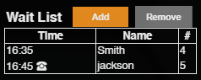

4. Table status colors and animations. **UNRESOLVED**

We won’t be able to make a decision on this matter until RestaurantLayout.php has been fully implemented and we can view the “big picture.” Some colors might not show up well, and others might clash. Animations for *highlighted* and *selected* were mentioned, but these have been assigned a **C** with regards to **MOSCOW**. The fallback is to have static, thicker borders around selected/highlighted tables.

